Project Summary

# Project Scope

The Sisters Cancer Support Group Android app was developed with the primary goal of providing a comprehensive platform for users to engage with the organization and its initiatives actively. Throughout the project's lifecycle, efforts were focused on fulfilling the app's original requirements while remaining adaptable to any necessary changes based on user feedback and testing. Below is a detailed account of the project's various aspects.

**1. Project Scope and Aims**

The project's scope encompassed the design, development, and deployment of an Android app that would help users engage with the Sisters Cancer Support Group. The main objectives included:

1. Designing and building an Android app customized for the Sisters Cancer Support Group's needs.
2. Incorporating features in line with essential and additional requirements
3. Delivering real-time event updates and notifications
4. Guaranteeing the app's user-friendliness and accessibility for a varied audience.
5. Facilitating user registration and post-sharing within the app
6. Enabling secure donation and ticketing processing
7. Offering access to various motivational content
8. Providing continuous support, maintenance, and updates after the launch

**2. Approach to Development and Methodology**

An iterative, agile-based approach was adopted for the development process, allowing the project team to accommodate changes and improvements as needed. Key stages of the development process involved:

1. Gathering and analyzing requirements
2. Designing and prototyping
3. Developing and implementing features
4. Conducting testing and quality assurance
5. Deploying and maintaining the app

Regular communication with the client and supervisor ensured that the project remained aligned with the organization's goals and user needs.

**3. Accomplishments and Implemented Features**

The Sisters Cancer Support Group Android app has successfully achieved its essential requirements and implemented several supplementary features to enhance the user experience. These include

1. Real-time event updates and customizable notifications
2. User-friendly registration, login, and post-sharing capabilities
3. Secure donation processing and ticketing with a variety of payment options
4. Access to motivational content, such as articles, videos, and quotes
5. Support for multiple languages
6. Customizable app settings like font size and notification preferences
7. Integrated calendar for easy event tracking
8. Efficient password management for enhanced account security

**4. Challenges Encountered and Solutions**

During the project, the team faced various challenges, including refining the user interface, ensuring accessibility for diverse users, streamlining the registration and login process, and implementing security measures for user data and donation processing. These challenges were tackled through iterative improvements, informed by user feedback, testing, and industry best practices.

**5. Appraisal and Future Enhancements**

The current state of the Sisters Cancer Support Group Android app aligns with its original goals and requirements. The app provides a comprehensive platform for users to engage with the organization and its initiatives actively. Although not all aspirational goals have been achieved, the app's foundation and added features make it a valuable tool for both the organization and its users. Continuous improvements based on user feedback and testing will further enhance the app's effectiveness and overall user experience. Potential future improvements include social media integration, in-app chat functionality, and an analytics dashboard for the organization to monitor user engagement and measure the success of events and campaigns.

# Project Charter

**Project Title:** Sisters Cancer Support Group Android App

**Project Sponsor:** Sisters Cancer Support Group

**Project Manager:** Kim Long

**Project Start Date:** September 1, 2022,

**Estimated Project End Date:** May 23, 2023

**Project Objective:**

Develop an Android mobile application to support the activities of the Sisters Cancer Support Group. The app will provide an interactive platform for cancer survivors and their supporters to share experiences, access motivational content, participate in events, and customize their notifications and language settings.

**Project Scope:**

1. Concept & Design: Design an intuitive and user-friendly app interface.
2. Backend Development: Develop the server-side components of the app.
3. Frontend Development: Develop the client-side components of the app.
4. Integration: Integrate the backend and frontend components.
5. Testing: Conduct thorough testing of all app features.
6. Feedback & Iterations: Make necessary modifications based on feedback.
7. Final Testing & Deployment: Conduct final tests and deploy the app.

**Deliverables:**

1. A fully functional Android application.
2. Documentation, including a user guide and technical specifications.
3. Post-launch support for a period to be determined.

**Major Milestones:**

1. Design completion (October 1, 2022)
2. Backend Development completion (Jan 15, 2023)
3. Frontend Development completion (April 24, 2023)
4. App Integration completion (May 1, 2023)
5. App Testing completion (May 8, 2023)
6. App Deployment (May 17, 2023)

**Stakeholders:**

1. Sisters Cancer Support Group: Will provide the requirements and oversee the project.
2. Project Team: Responsible for the development, testing, and deployment of the app.
3. End-Users: The users who will use the app once deployed.

**Risks:**

1. The project timeline could be delayed due to unforeseen technical challenges.
2. User acceptance of the app may not be as expected.

**Gantt Chart**

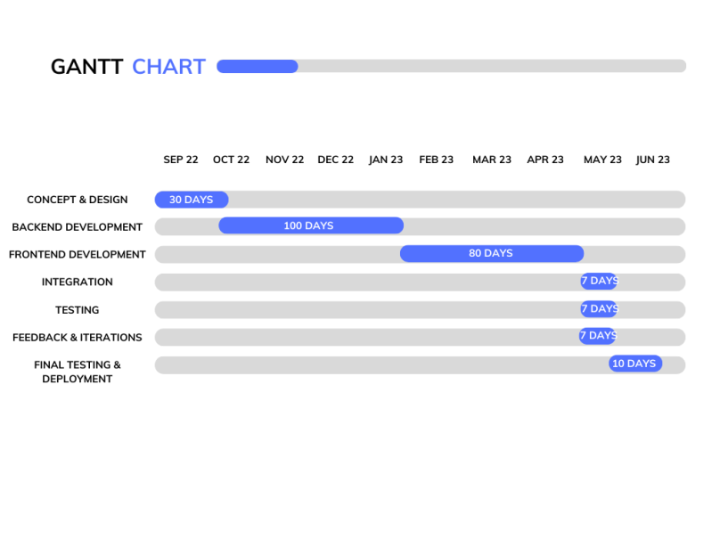

.

Marketing

# Knowledge of the issue /client

Cancer is a devastating disease that affects millions of people worldwide. It not only causes physical pain and suffering, but it also takes a tremendous emotional toll on patients and their families. The diagnosis of cancer can be overwhelming, and the treatment and care for cancer patients can be a lengthy and arduous process. There is a need for greater awareness and understanding of the disease for those who are affected by cancer. This is where a social platform plays a crucial role to spread knowledge about the disease, its causes, and its effects. Additionally, it can provide information about available treatments, caregiving options, and resources for those in need. This can also help to connect cancer patients, survivors, and their families, allowing them to share experiences, offer support and advice, and find comfort in their shared journey as a platform for patients and families to raise awareness of cancer and its effects, as well as fundraising efforts for research and support charities.

In this project, after carefully analyzing the needs and requirements of the end users and the stakeholders, we have designed a mobile-based application as a digital health platform for those struggling with Cancer. The Sisters Cancer Support mobile application aims to provide a patient-tailored support system with a more proactive approach towards managing cancer-related issues. The main focus while developing the application was to provide users with a simple yet intuitive design to navigate, learn and use. The application is tailored to provide users with various spectacular features like

# In-Depth Target Market Analysis for the Sisters Cancer Support Group Android App

For the successful development, launch, and adoption of the Sisters Cancer Support Group Android app, it's crucial to gain a deep understanding of the target market and its various segments. This knowledge will help guide the app's design, features, and marketing strategies, and provide insights into user preferences and behaviors.

**1. Segmenting the Market**

To better comprehend the target market, we can break it down into several segments based on distinct characteristics or needs:

1.1 Age: While cancer affects individuals of all ages, the app's design and features should be tailored to specific age groups that are more likely to use mobile apps. In this project, the specific targets we are looking to advertise to are middle-aged women who have been through or have family members who have gone through cancer treatment. With the ever-expanding need for technology, even a non-tech-savvy person should know a few piece of tool to improve their communication within their social circle

1.2 Gender: Even though the app is called "Sisters Cancer Support Group," it's essential to acknowledge that cancer impacts both men and women. The app should strive to be inclusive and consider the needs of all genders.

1.3 Cancer Type: Different types of cancer may require diverse support resources and information. The app should be capable of catering to the varied needs of users dealing with multiple types of cancer.

1.4 Emotional Needs: Users might have different emotional needs, with some seeking inspiration and motivation, while others may be looking for empathy, understanding, or practical advice. The app should be equipped to address these various needs through its content and features.

1.5 Geographical Location: Users from different countries and regions may have unique preferences, cultural backgrounds, and healthcare systems. The app should be able to support multiple languages and offer region-specific content and resources when possible.

**2. Estimating Market Size and Potential**

Calculating the market size and potential for the Sisters Cancer Support Group Android app involves understanding cancer prevalence, the number of individuals affected (directly and indirectly), and the potential user base that could benefit from the app.

According to the World Health Organization, cancer is the second leading cause of death globally, responsible for approximately 10 million deaths in 2020. Taking into account the number of individuals affected by cancer, along with their friends, family members, and healthcare professionals, the potential target market for the app is substantial.

With smartphone usage and mobile app adoption continuing to grow worldwide, the potential user base for the Sisters Cancer Support Group Android app is expected to expand in the coming years.

**3. Uncovering User Needs and Preferences**

To make sure the app meets the needs and preferences of its target market, it's essential to conduct user research. This could include surveys, interviews, focus groups, or user testing sessions. By collecting insights from potential users, the app can be designed and developed to address the specific pain points, preferences, and expectations of its target audience.

**4. Keeping Up with Market Trends**

Staying informed about market trends and emerging technologies can help the app maintain its relevance and competitive edge. Some current trends in the cancer support app space include telehealth integration, AI-powered personalized content, and mental health support.

By carrying out a comprehensive target market analysis for the Sisters Cancer Support Group Android app, the development team can make informed decisions about the app's design, features, and marketing strategies. This will ultimately contribute to the app's success and its ability to positively impact the lives of its users.

# Description of Benefits of the Sisters Cancer Support Group Android App

The Sisters Cancer Support Group Android app offers numerous benefits that set it apart from its competitors and address the unique needs of its target audience. These benefits contribute to the overall value of the app and can increase user engagement and satisfaction.

**1. User-friendly Design**

The app's design focuses on ease of use and accessibility, ensuring that people from different age groups and technical backgrounds can effortlessly navigate and fully utilize the app's features.

**2. Customized Content**

The app provides tailored content to users based on their preferences, cancer type, and emotional needs. This personalized approach guarantees that users receive the most relevant information and support, enhancing their overall experience with the app.

**3. Easy Event Integration**

With built-in event calendars and notifications, the app simplifies staying informed about upcoming events and initiatives, encouraging active participation within the community.

**4. Commitment to Improvement**

The app embraces an agile mindset, allowing for ongoing refinements and enhancements based on user feedback and evolving market trends. This ensures the app remains valuable and up-to-date for its users over time.

## 

## 

## 

# Marketing Mix for the Sisters Cancer Support Group Android App

The marketing mix represents the blend of strategies and tactics employed to promote and sell a product. For the Sisters Cancer Support Group Android app, the marketing mix can revolve around the 4 Ps: Product, Price, Place, and Promotion.

**Product**

The app's key features and benefits, as described above, form the foundation of the product offering. The development team should continue to fine-tune and expand the app's features based on user feedback and market research to ensure it consistently satisfies users' needs.

**Price**

As the app is created by a non-profit organization, the Sisters Cancer Support Group Android app can be provided as a free download to users. This pricing strategy guarantees that the app is accessible to the widest possible audience and supports the organization's mission of offering support and resources to those affected by cancer.

**Place**

The app should be accessible through popular app stores, such as Google Play Store, and promoted on the Sisters Cancer Support Group's website and social media channels. This ensures that the app is easily discoverable and reachable to potential users.

# Promotion

Various channels can be used to promote the app, including:

* Social media campaigns targeting the app's specific audience
* Partnerships with influencers, such as cancer survivors and healthcare professionals, to raise awareness and trustworthiness
* Email marketing campaigns aimed at the Sisters Cancer Support Group's existing members
* Collaborations with other non-profit organizations or healthcare providers to increase reach and visibility.

By skillfully employing the marketing mix, the Sisters Cancer Support Group Android app can raise awareness, attract new users, and ultimately deliver meaningful support to individuals affected by cancer

TECHNICAL REPORT

# System Requirements

**1. Essential Requirements**

The foundation of the Sisters Cancer Support Group Android app was built upon several crucial requirements that provide users with a platform to connect and engage with the organization and its various activities. These requirements include:

1.1 Keeping users informed about events: The app delivers up-to-date information on upcoming events and offers users the option to receive notifications for specific events.

1.2 Easy account creation and post sharing: Users can effortlessly register and post content within the app.

1.3 Availability of motivational resources: The app offers users access to a range of motivational materials, such as articles, videos, and quotes, for support and inspiration.

Conclusion: The app has met the main requirements that clients issued such as allowing users to view admin content on the homepage, have an event organizing function and be able to allow the admin to send notifications to users at will

**2. Supplementary Requirements**

To elevate the user experience and cater to the diverse needs of the app's audience, several additional features have been introduced:

2.1 Language support: The app accommodates users from various linguistic backgrounds by offering multiple language options.

2.2 Personalized settings: Users can tailor their experience by adjusting settings, such as font size, notification preferences, and high-contrast mode.

2.3 Integrated calendar: A built-in calendar feature allows users to view and add upcoming events to their calendars, ensuring important dates aren't missed.

2.4 Easy password management: Users can conveniently change their passwords to maintain account security.

Conclusion: Some additive requirements have been successfully implemented to improve user experience such as having personalized settings as the app is fairly simple to design and can quickly understand, the integrated calendar has been added inside event creating function but only the admin has access to it normal users can view the specific time listed in each event post and finally there are functions in the menu dashboard to guild user to SCSG’s website. The host website will be providing users with useful information such as how to contact to volunteer or donate to the organization

**3. App Evaluation**

The Sisters Cancer Support Group Android app effectively meets all the essential requirements and several supplementary requirements. By focusing on user-friendliness and accommodating various user needs, the app aligns with the organization's objectives.

Although not all aspirational goals have been reached, the app's foundation and added features make it a valuable tool for both the organization and its users. The app's effectiveness and overall user experience can be further enhanced by incorporating user feedback and testing into future iterations.

# Iteration Management

An agile-based approach was used to effectively manage the development process by dividing the project into smaller, more manageable iterations. This iterative process enabled the project team to be more receptive to changes and improvements based on user feedback and testing. Crucial steps in managing iterations included:

+ Setting short-term objectives for each iteration, focusing on achieving specific goals or completing a series of tasks

+ Regularly reviewing progress and adjusting upcoming iterations based on lessons learned, user feedback, and testing outcomes

+ Encouraging open communication among the project team, client, and supervisor to maintain alignment with the organization's objectives and user needs

+ Reevaluating the project's scope and altering priorities as needed to accommodate new insights or requirements emerging during development

+ Continuously keeping track of the project's progress, quality, and risks to identify and address any issues promptly

Through a well-defined scope and a solid iteration management process, the Sisters Cancer Support Group Android app was developed in a controlled and flexible manner. This approach allowed the project team to deliver a top-notch app that meets the organization's objectives and caters to the diverse needs of its users while remaining open to ongoing improvements and refinements.

To ensure a seamless user experience with the Sisters Cancer Support Group Android app, your device must meet the following minimum requirements:

* Android OS version 6.0 (Marshmallow) or higher: This requirement ensures that the app remains compatible with the majority of Android devices while taking advantage of the latest features and improvements offered by newer Android versions.
* A stable internet connection (Wi-Fi or mobile data): The app relies on real-time data updates for events, posts, donations, and content. A stable internet connection ensures that users can access and interact with these features without disruptions or delays.
* A device with at least 1GB of RAM and 100MB of free storage space: The app has been optimized to run smoothly on devices with limited resources. However, it is crucial to have at least 1GB of RAM for efficient multitasking and 100MB of free storage space to accommodate the app's installation and any additional data, such as images and videos, that may be downloaded while using the app.

Here is a snapshot history of how the team manage and keep track of different coding interaction by updating and slipping into branches using GitLab

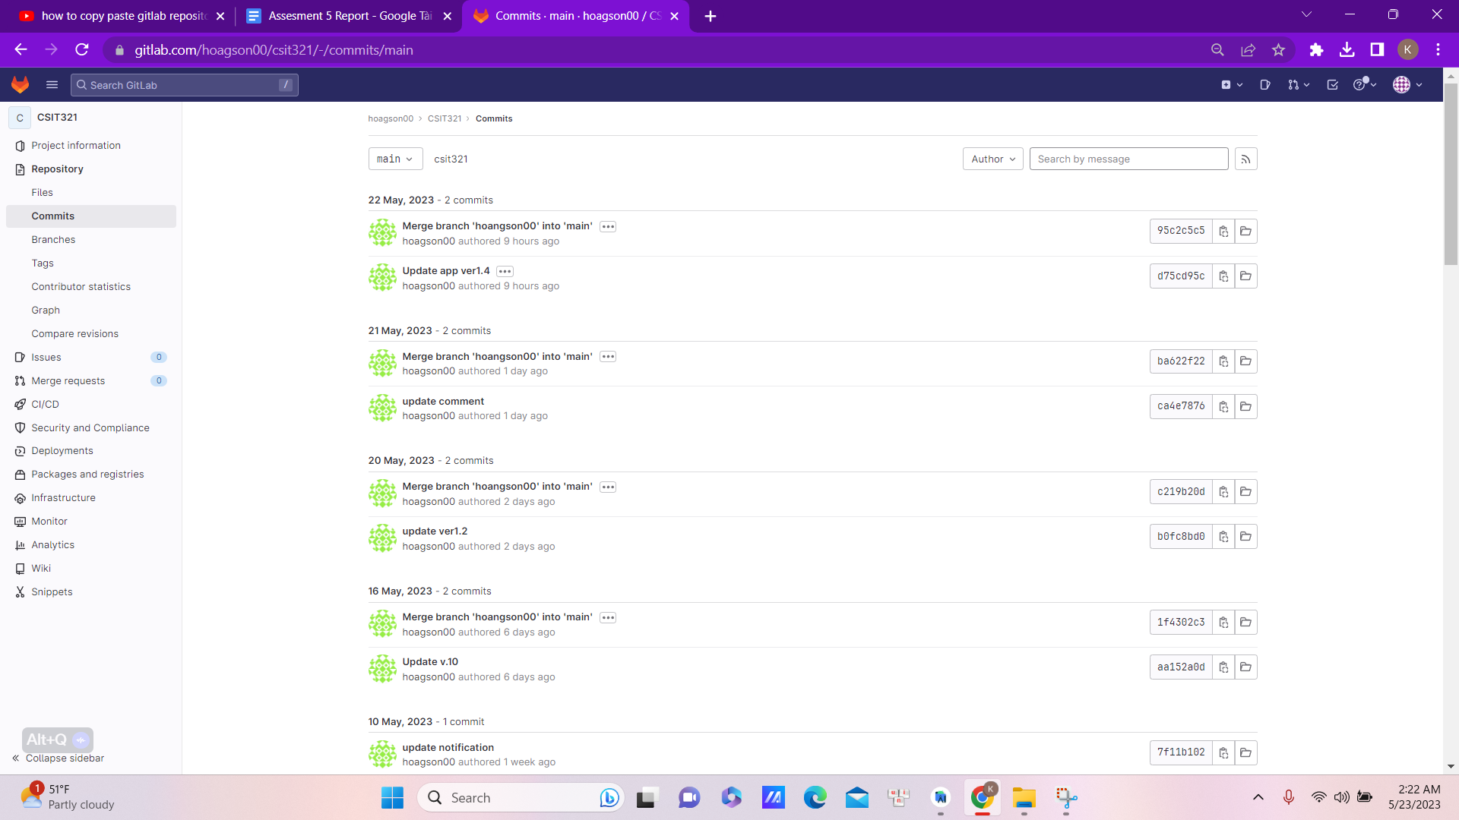

## Design Iteration

Over the time period of 1 year, our design has been through some modifications

+Original Design

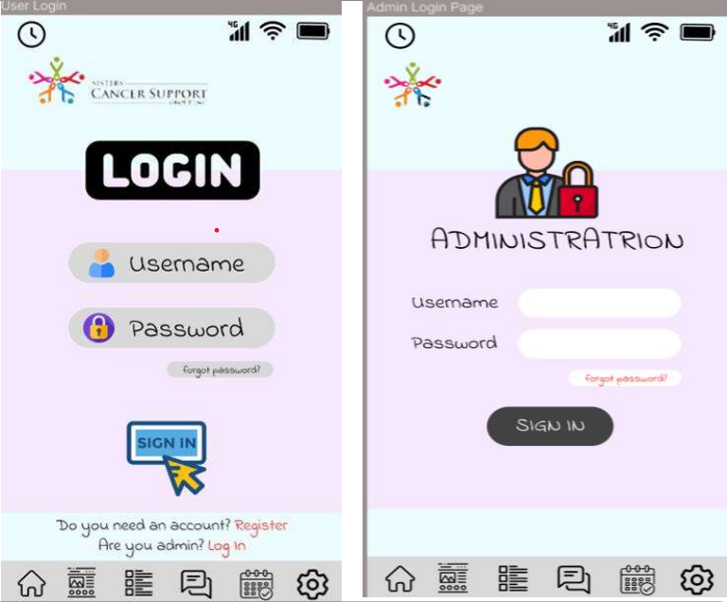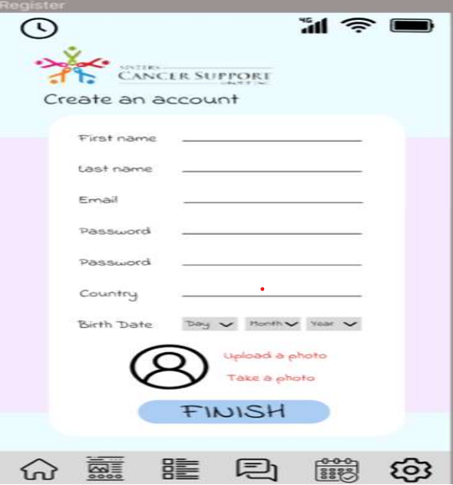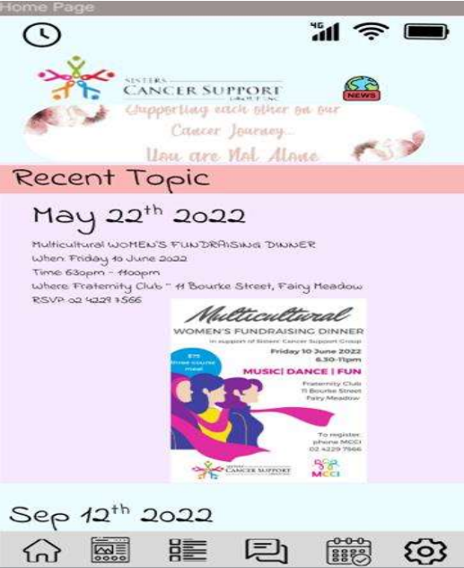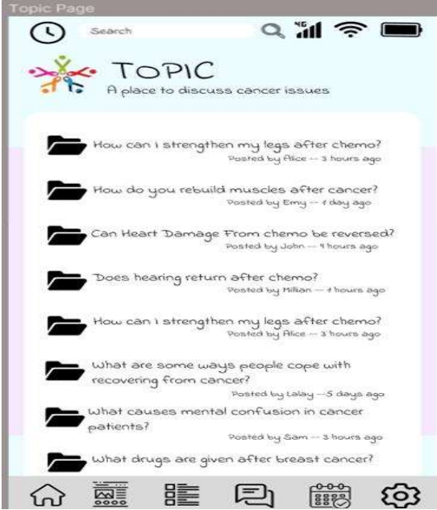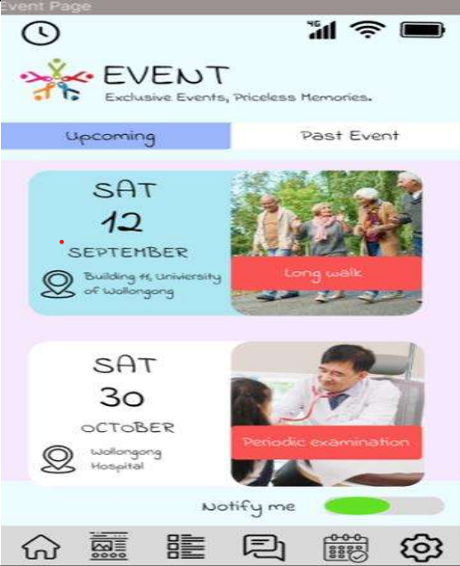

When the team first presents the design to the project supervisor and client, there were a few big issues that needed to be addressed. Firstly, the colour palettes are all over the place, with no clear concept or purpose as to why the team decided to choose those specific colours. Secondly, the choices for icon illustration do not appeal to the intended target primarily (for middle-aged women, all the buttons look a bit cartoonish and lack the maturity they are hoping for). And the third and final huge adjustment is to the required fields in the registration form. For that specific UI, what the client side was hoping to collect was the user's full name instead of splitting it into two separate sections. Email or phone could be used side by side meaning the system can accept either just one or both pieces of information since not all group member of Sister Cancer Support Group has created an email and the date of birth field should be changed to “Why are you signing up”.

After that feedback, the team brainstormed and come up with the second design idea

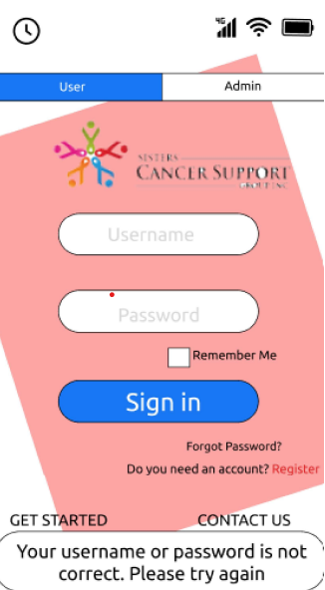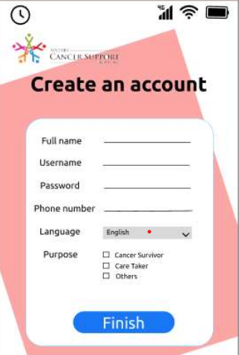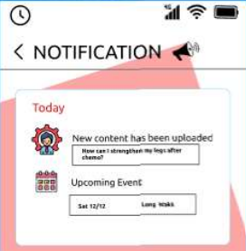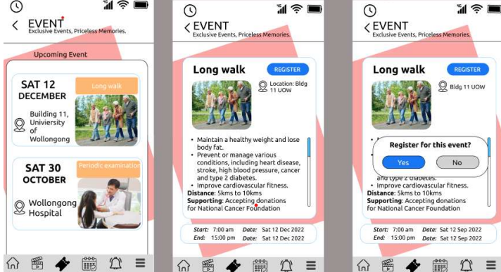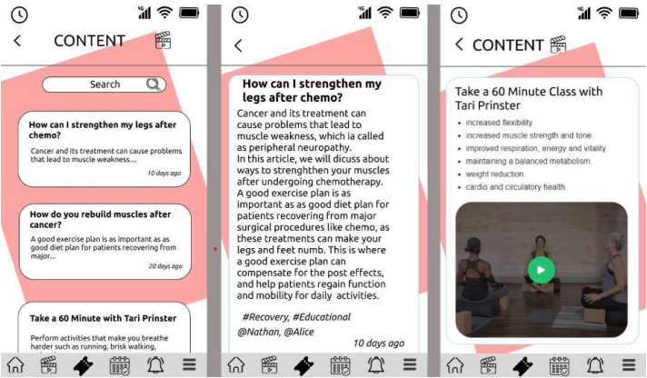

In this second design board, a clear marketable decision has been made regarding the choice of the colour pallet

. 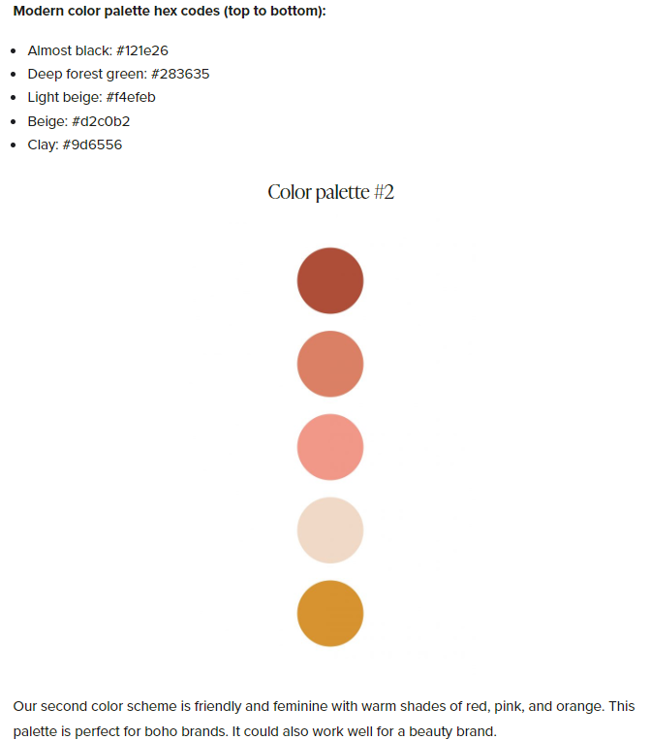

Taking inspiration from this internet colour pallet, the design team has picked out the main theme for the app UI will be pink and white. This colour pallet just happens to also be aligned with Sister Cancer Support Group’s website colour pallet. Overall, these colours complement each other creating that warm and welcoming feeling that fits the purpose of our application.

There is one final redesign of the app UIs and that is when the team start implementing this app in real-time. Some functions have been simplified and re-allocated to optimize how the flow of the system should work

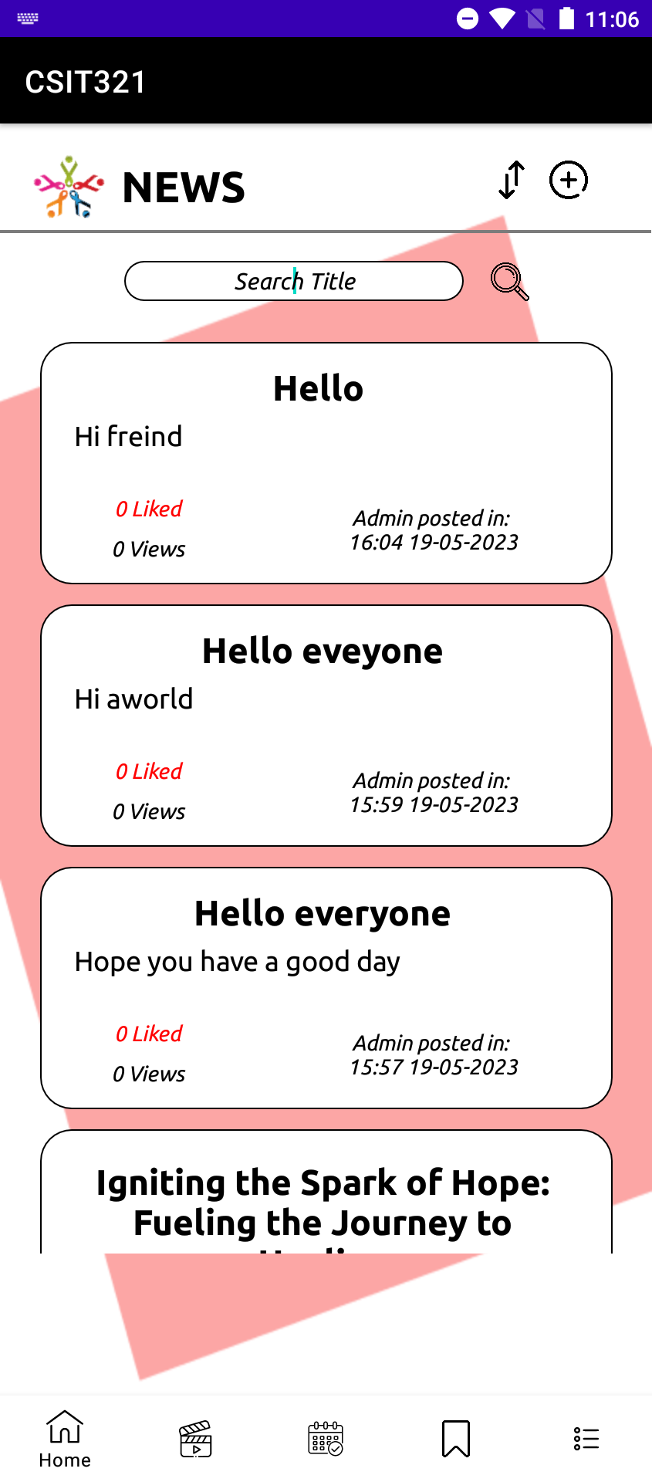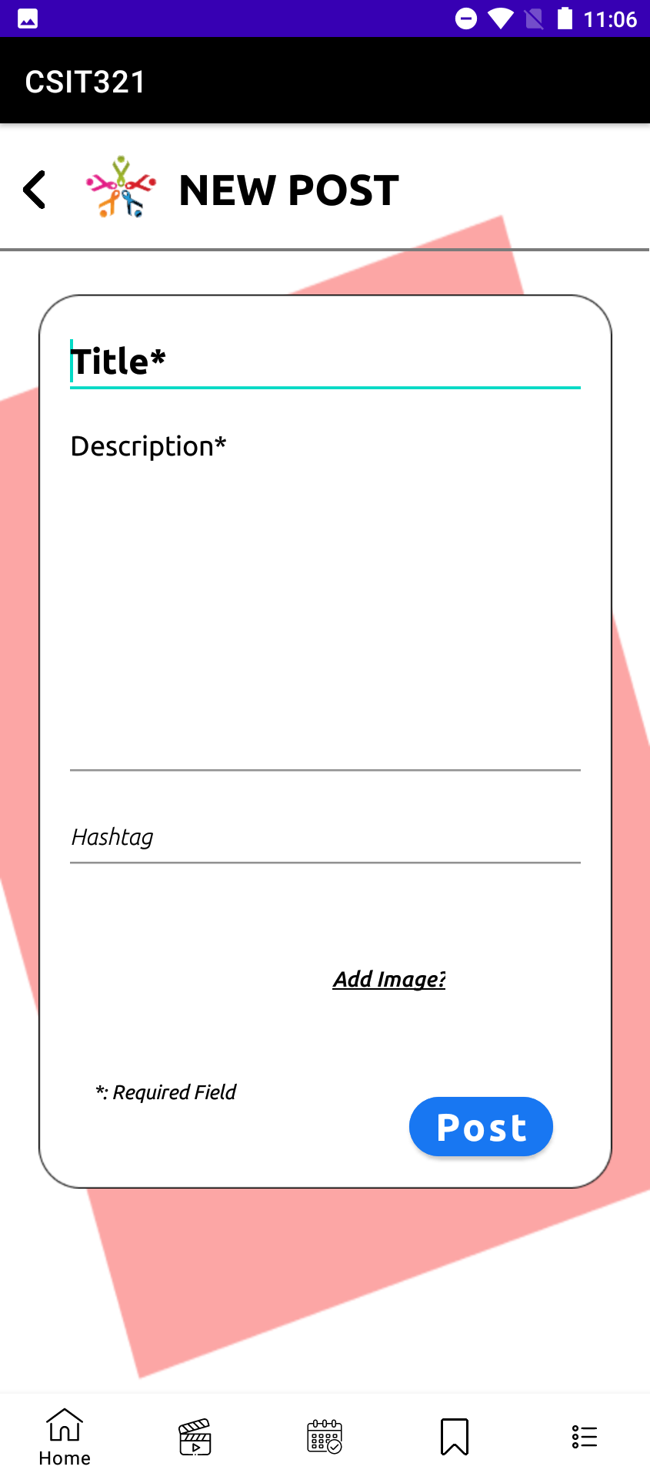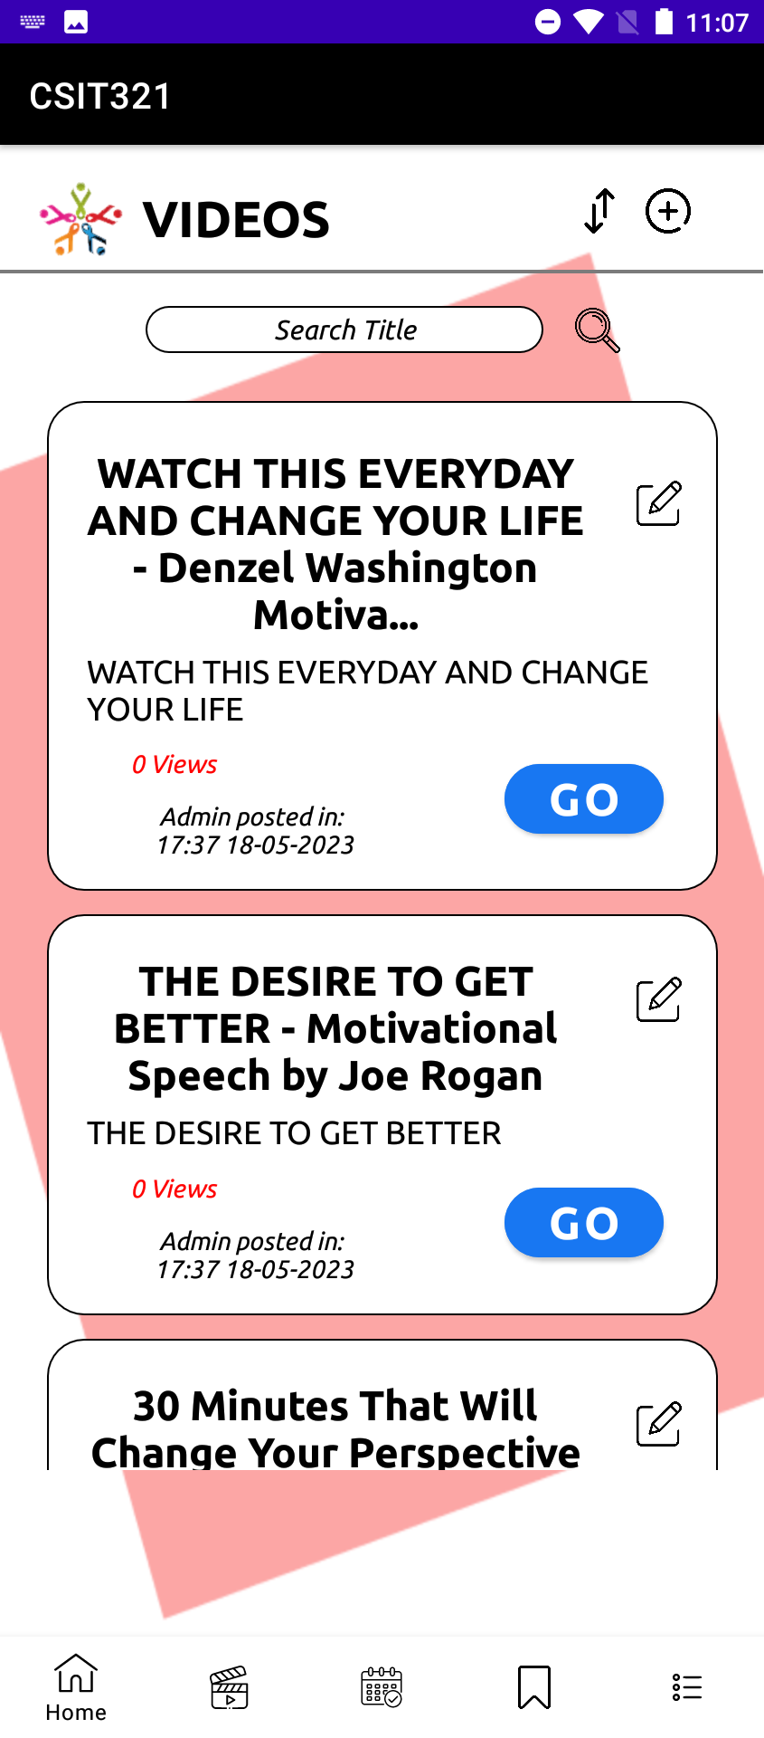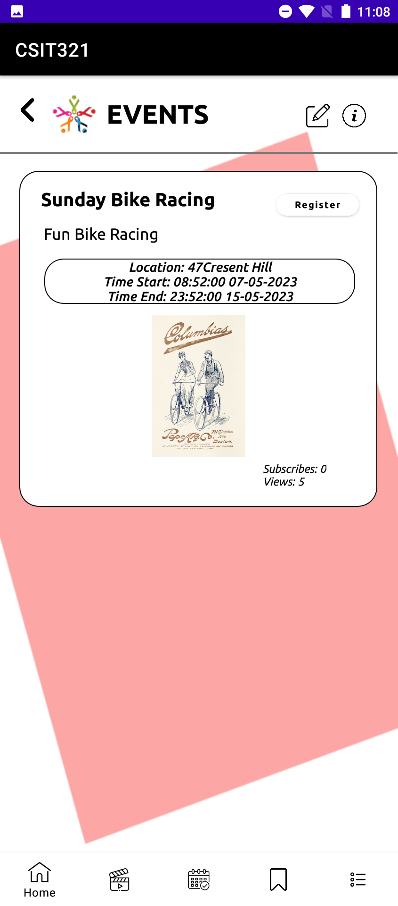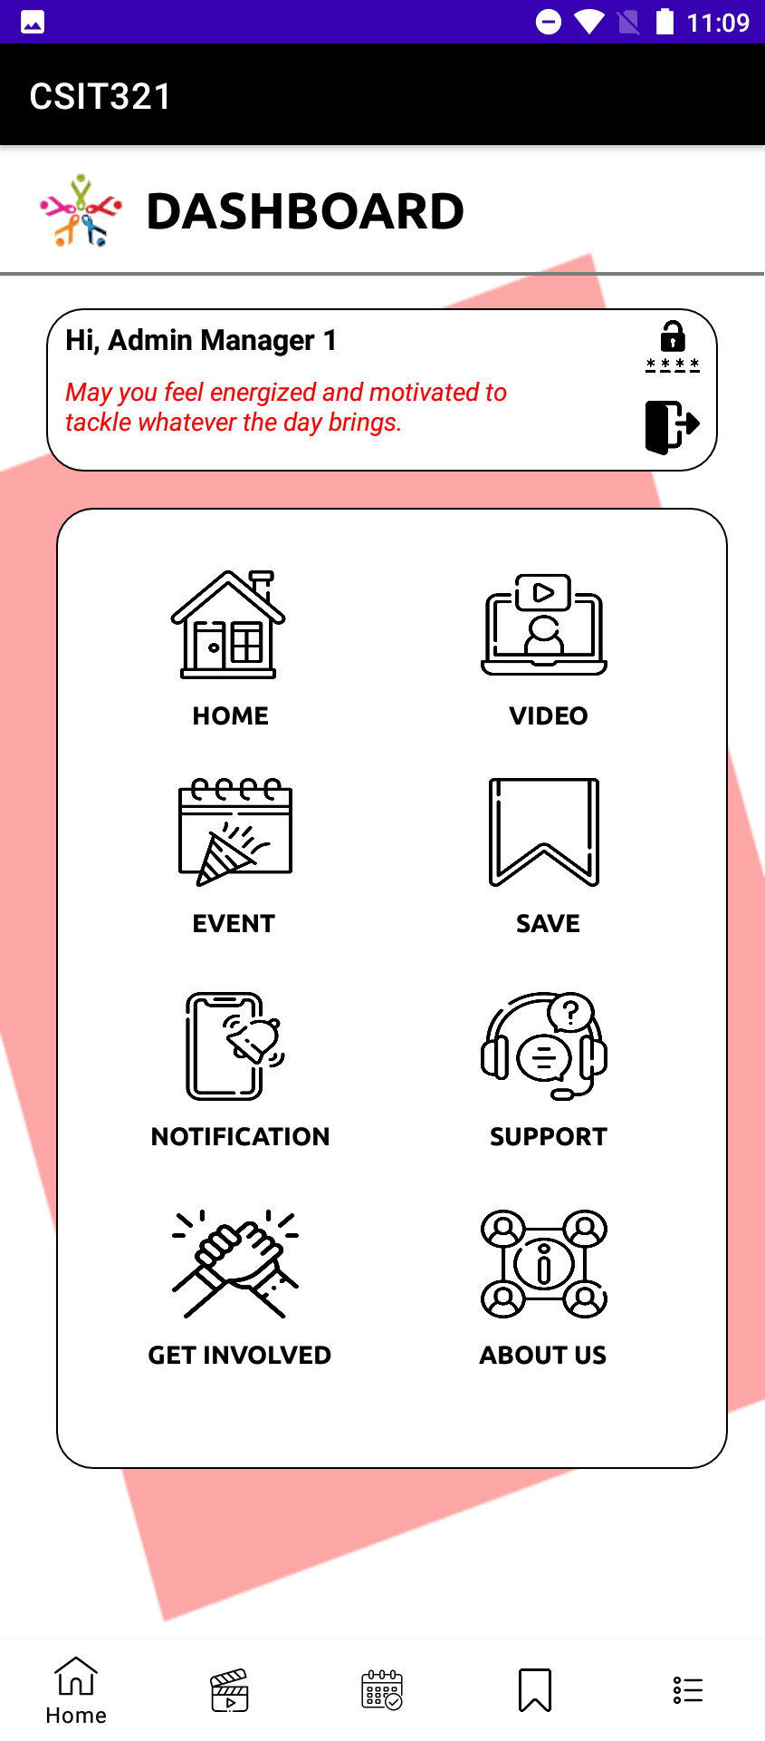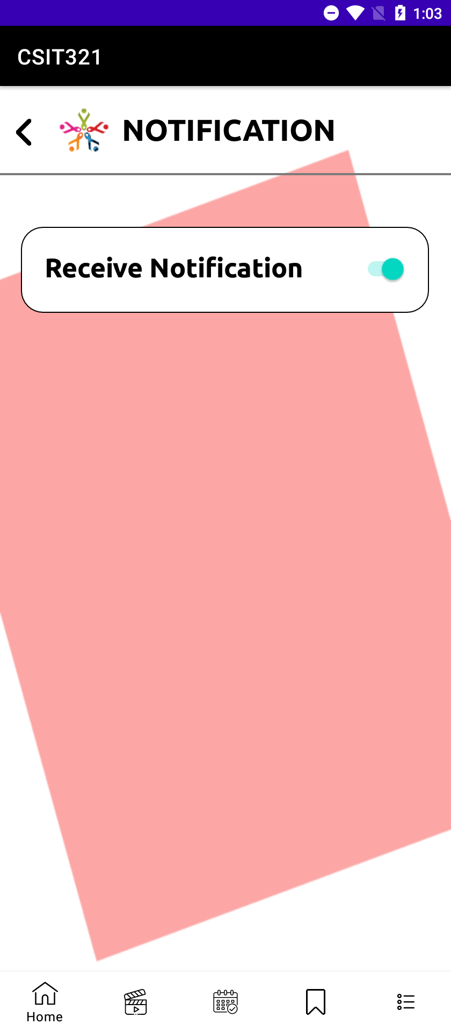

In this final design, the location of where the educational content (admin post) has been defined. In the second design where there is a dedicated section to store admin posts, that has been moved to be displayed on the homepage so users can firstly see what the admin has uploaded when they access the app. The notification page has been simplified so that when the user just needs to click on the button to receive messages directly from the admin as opposed to the lengthy process in the previous design.

## System Design

The project database UML Schema:

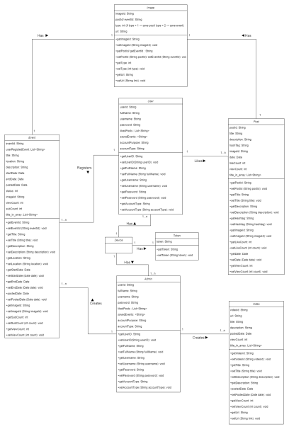

Specific look into each class

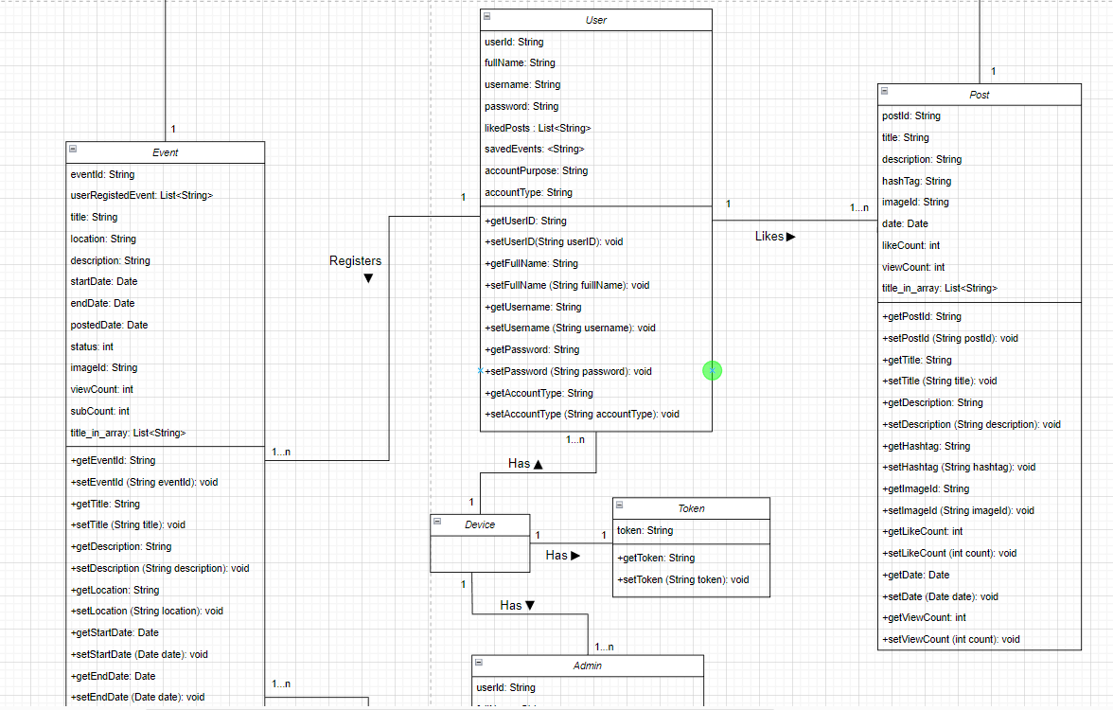The device class can be accessed by two types of users admin and group members and a token class is created to use for authentication (so the system can distinguish between users whether they are normal users or administration)

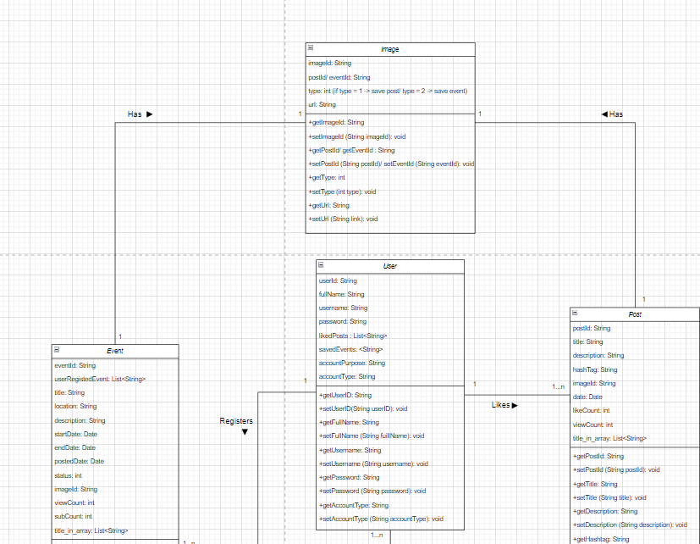

Normal user will can view links that the admin has posted in the video section as well as register for the specific event they intended to participate

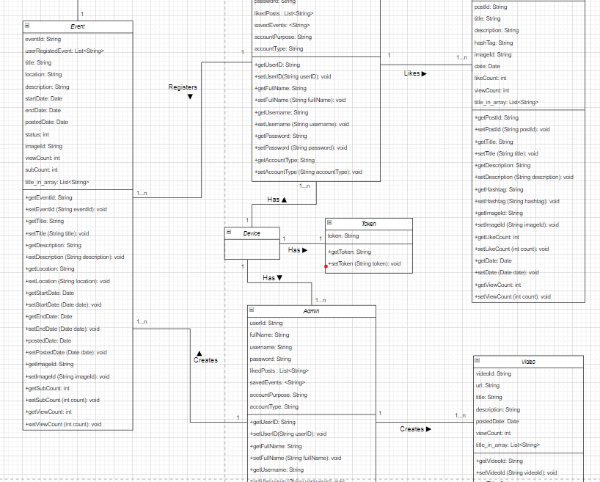

Admin will also has full access just like user and with an additional feature to allow them to create new events, posts and putting video links to the website

Database Storage:

For this project, the team use Firebase web application to store the data. Here some of the samples of what the team database looks like:

Event: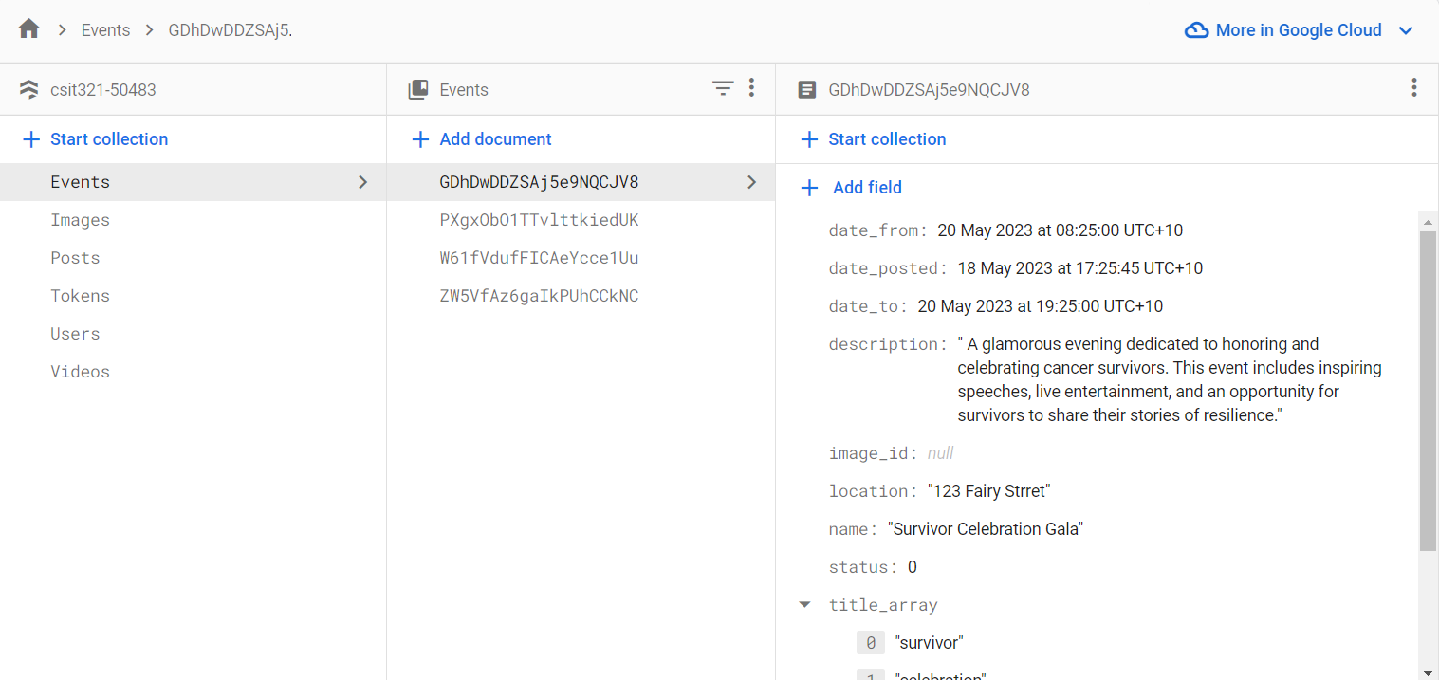

Image:

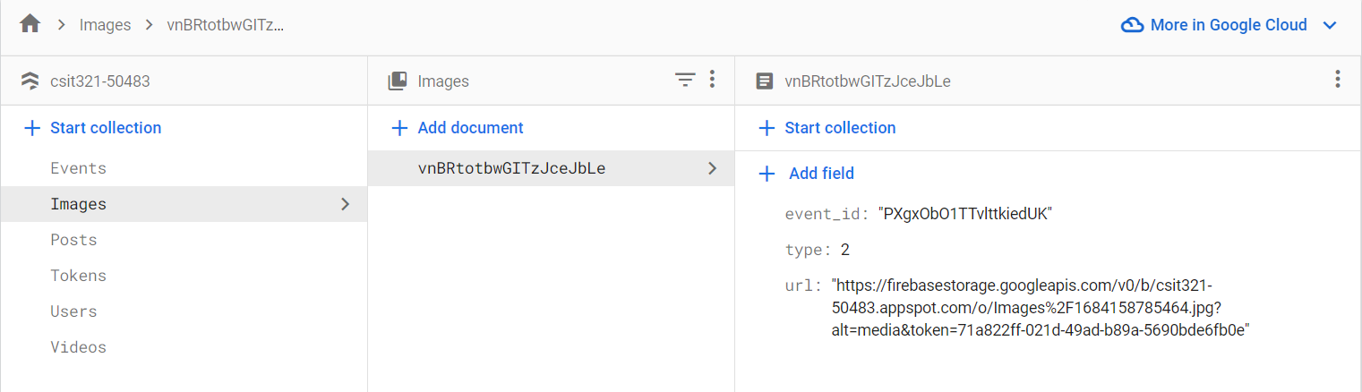

Post:

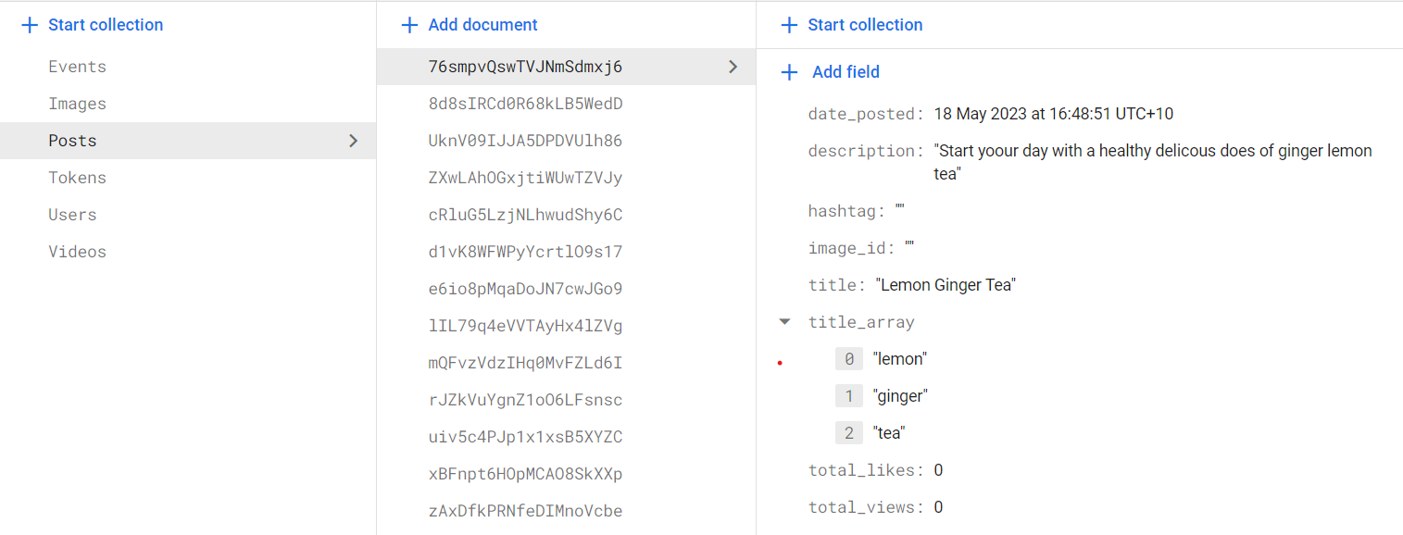

Token:

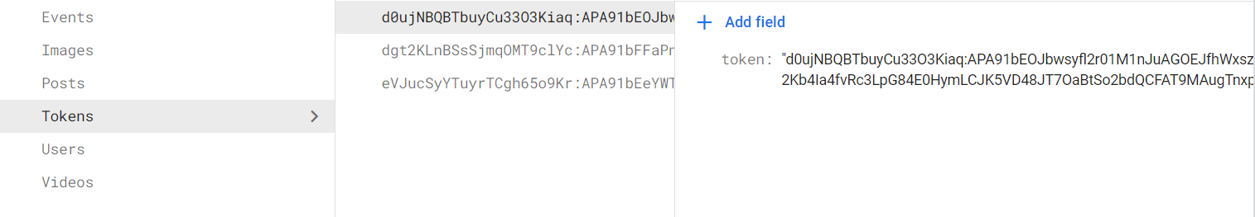

Users:

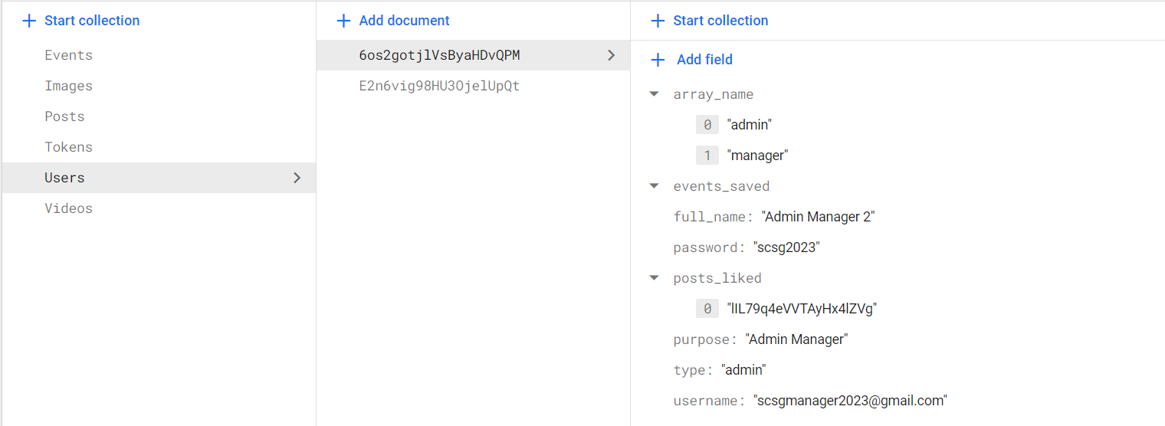

Video:

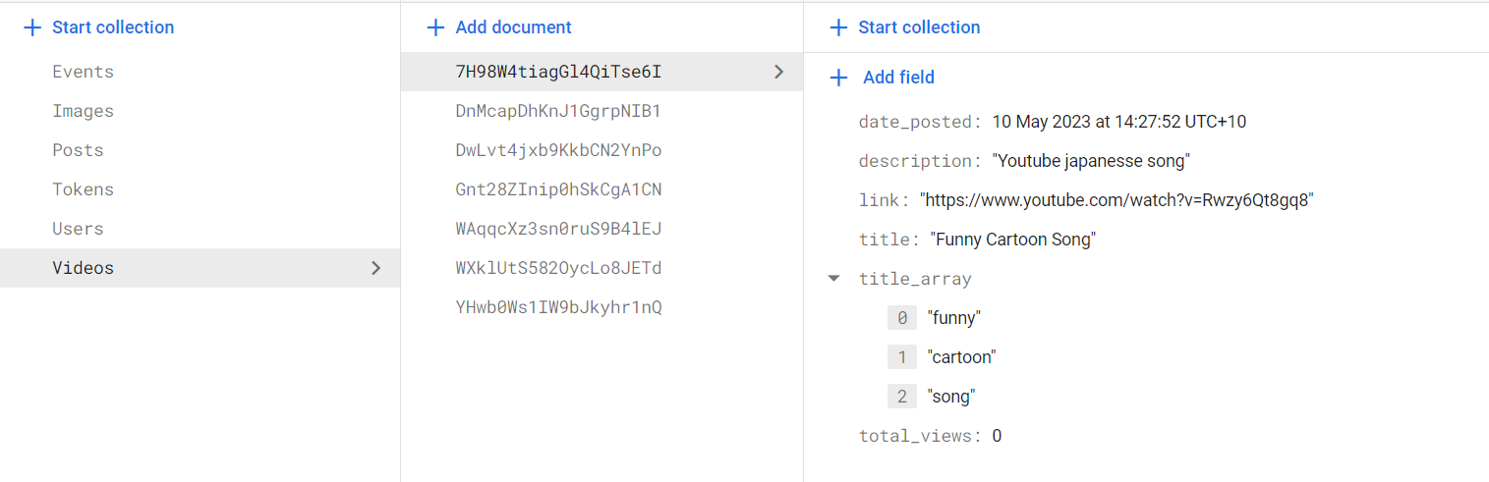

USER MANUAL

The target audience for this mobile application will mostly be mature, middle-aged women who have experienced cancer either directly or second-hand as patients’ family members. The clients with whom the engineering team is working are not too keen on technology, and with that in mind, the team has tried to make the product design’s outlook as simple and familiar as possible.

Starting off, when the user clicks on the app icon it will show a staring page filled with the client’s background information and a button upon clicking will direct the user to the app homepage

StartingPage HomePage

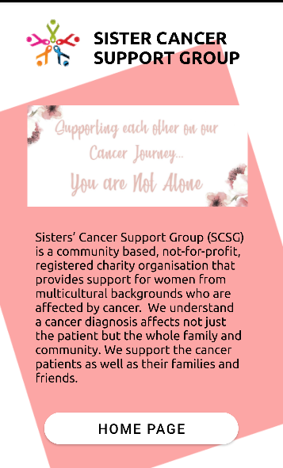 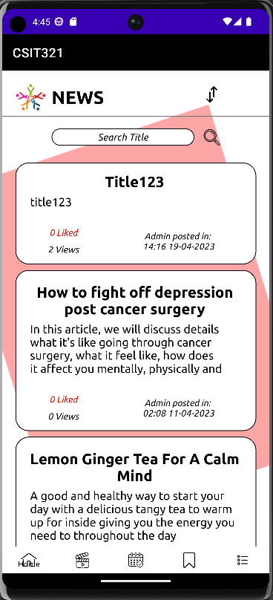

This UI shows all the posts the admin has uploaded onto the app, ranging from the latest to the oldest ones. At the page header, next to the client’s logo is the filter function, by clicking on that button, a drop-down menu bar will appear for users to tailor to their desired content. These filter options include:

**Filter Function** NavigationBar

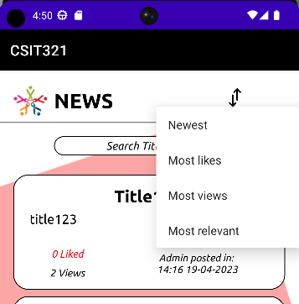 

**Post Detail**

To view each specific post simply by clicking on that post and the full details will be displayed. The format of each article must include a title and the context of that post

One of the beneficial features we made is that the app is accessible even without a user login. However, if the user signs in they will have access to the Save feature. Here users can freely save their favourite content for re-watching purposes. To access this feature first user can press the heart icon in each post and then go to the navigation bar down below. The second icon from right to left is where users can find their stored contents

**THE HEART ICON (for each post)**

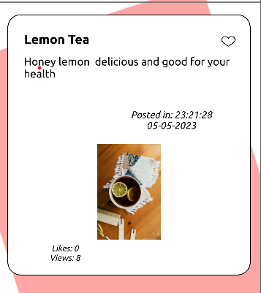 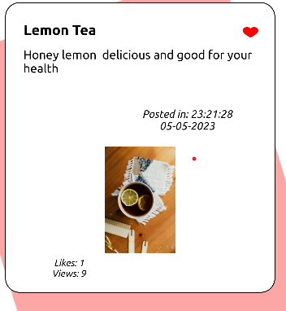

**BEFORE AFTER**

**Save function**

 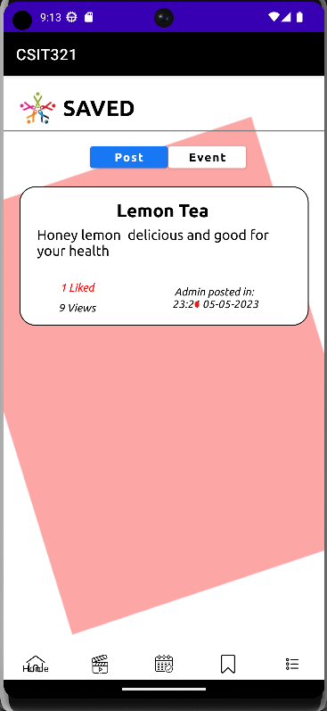

**Icon Content Storage**

Next to the home icon in the navigation bar is the video icon. This is where the user can find video links the admin has posted. Users can only click on the bright-blue “Go” button, upon clicking it will redirect them to the designated youtube page

**Video Function**

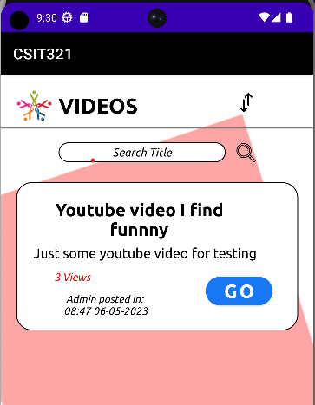 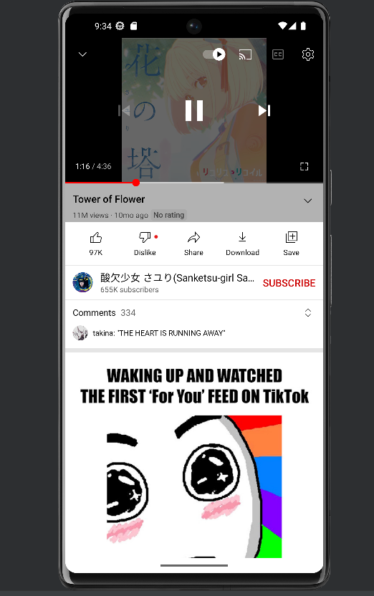

**Before clicking the “Go” button After clicking**

Moving on, next to the video icon will be the event icon, on the same working principle of educational content posted on the homepage, users can tailor the order of the events to their liking including a re-appearance of the filter feature in the header space. In addition, the event sight also includes features such as searching for a specific event by typing its title in the search bar and another search function but its search engine is based on the time and date of the events. Similar to how posts work, users can click on each event to view their specific description. For the searching function to work properly, the user needs to type in the keyword that is in the event they are looking for and then hit the scope icon to activate the search function

**Event Function**

 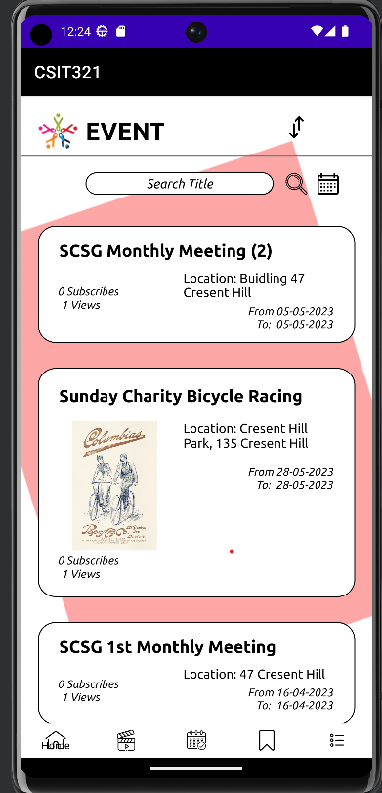

**Event Icon Default Event UI**

**Available Function on Event UI**

 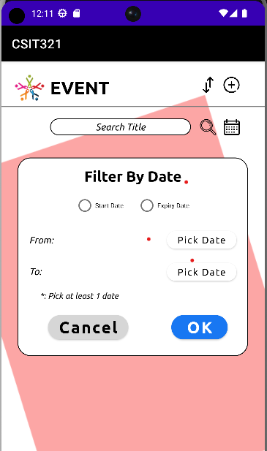 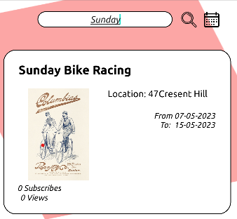

**Filter by time icon Filter by time menu Search function by typing**

One final feature in the navigation bar is the dashboard menu

**Dashboard Function**

 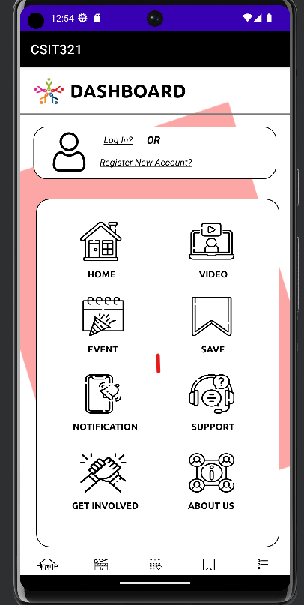

Dashboard Icon Dashboard UI

**Support**

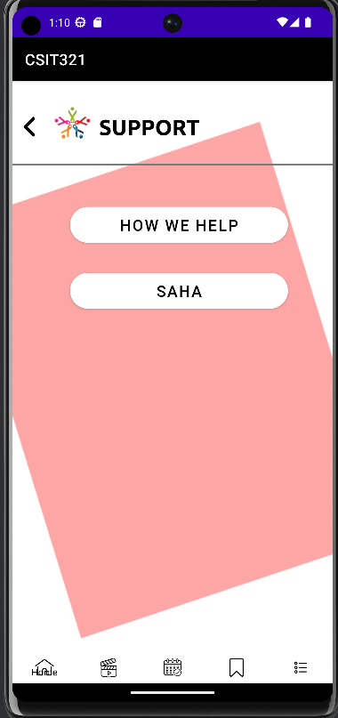

The support options include two sections that provide information about the organization. The first button will get users to the client's website where there are instructions on how they can help or donate to the organization. The last button will show them the section of their webpage describing SCSG’s goal, motto and what are they trying to accomplish

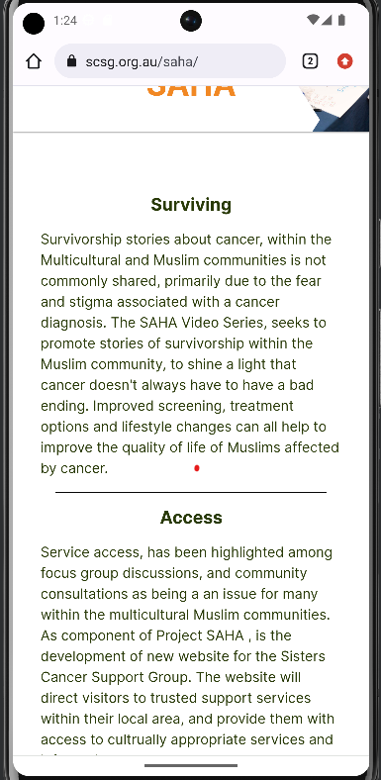 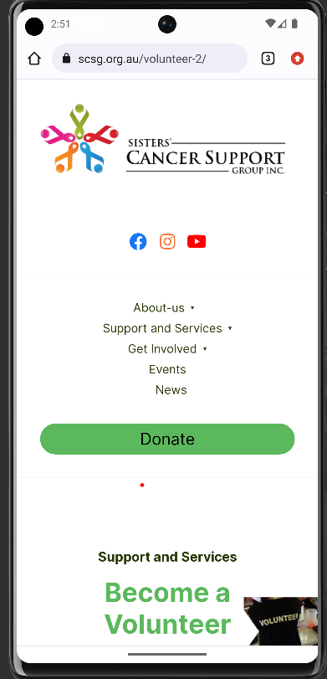

**SCSG’s Motto Get involved**

**About Us**

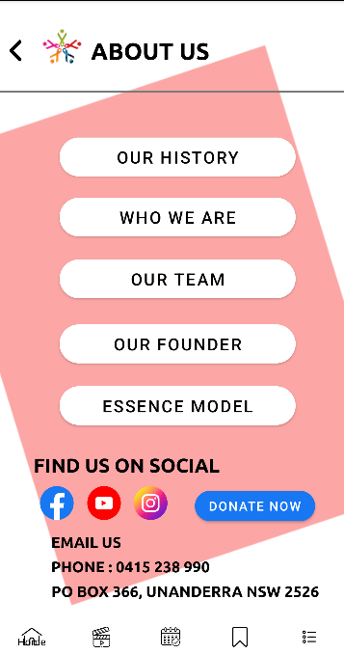

Here users will find useful information about the background of the Sister Cancer Support Group volunteer group as well as their associate social links

**Log-in Page**

In the DashBoard function, there is also a login option for the user near the top of the header. The overall design of the Log-in page is self-explanatory Users fill in their details in the appropriate fields if they already have an account; otherwise, there is a “Create New Account” button just below the bright login sign. Clicking on that button will direct you to our registration form. The register form consists of data fields that our clients are interested in such as email or phone, user’s full name, phone number and their purpose for joining the app.

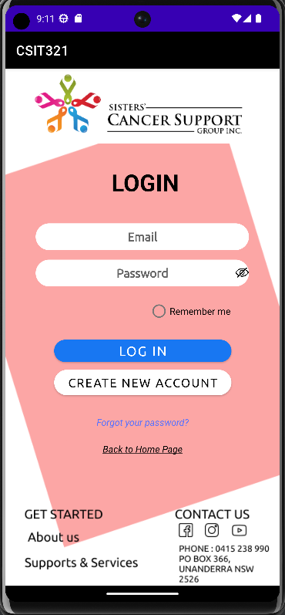 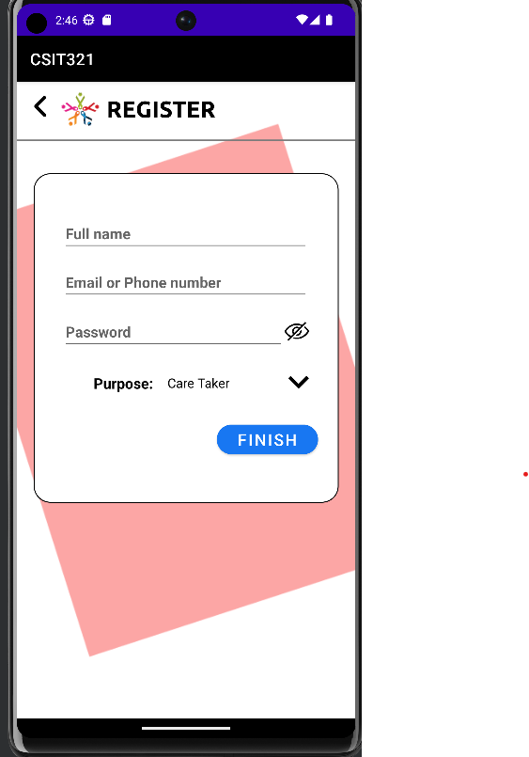

**Log-in UI Register UI**

**For the administration side**

By logging in using the admin account, user UIs will now have added features that allow the controller to write, and create new posts, and events, as well as fix or delete these items. User can see new icons appear, for creating new posts a plus sign icon is in place next to the filter option. As for the editing and deleting post will appear once the admin click in the specific details of the post like what has been demonstrated above for normal user

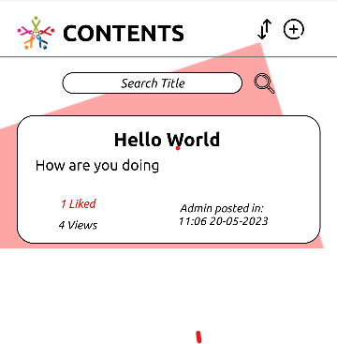 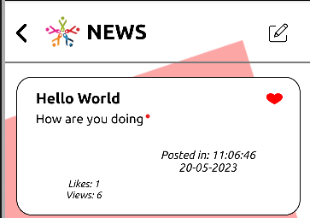

**Add Content**   **Edit Content** 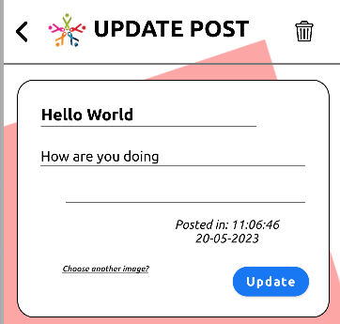 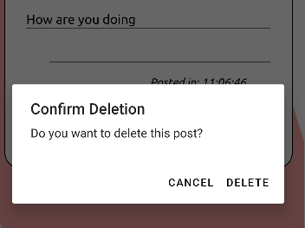

**Delete Content Delete Confirmation**

Finally, all the source code files for this project will be uploaded to Google Drive and the developer team will hand out code for clients to access the folder for download. Once they have successfully installed the APK with an appropriate setting in the device an icon of the Sister Cancer Support Group should appear as the logo for the application

# System installation process

To have this project operate at optimal run time, the user will need to run this project on any Android-supported IDE (Integrated Development Environment). Android Studio is the perfect candidate for this project with abundant online resources and forums to support the newbie developer team. For optimal simulation of a real-life Android phone, we create on the IDE emulator a virtual phone iPhone6 Pro API33

To view the database storage, the user must first have an account on FireBase and then request authentication access to the project. Once all the prerequisite requirements have been met, a UI dashboard containing this project-created data should appear

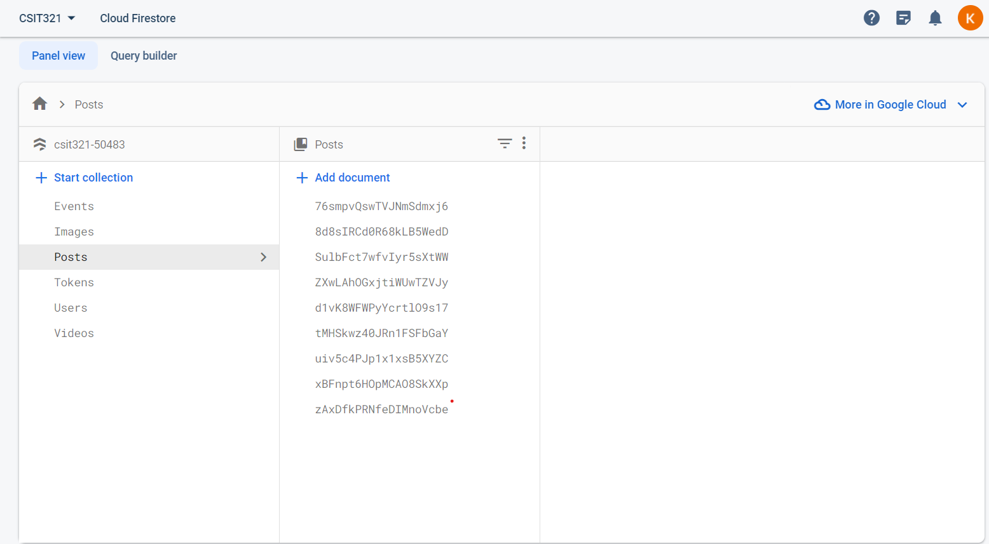

Project Closeout

**Lesson Learned:**

By completing this project from start to finish there are always hidden issues that rose up non-stop that need the team as developers to review and communicate with the clients/ project supervisor for optimal project growth. For this team, the first phase of creating the demo design could say is the hardest because what the team has for demo design doesn’t really align with the client’s desires so that took a lot of time to rework. One good thing the team learnt is how great the Agile method really is in real- life by communicating with many stakeholders (supervisor, clients, different background group members), the team manage to adverse all the trouble the project post as well as hidden issues that rose up doing real-life coding implementation.

**Post Project Review:**

Overall, this was a fun and very meaningful project. we get to work with some of the nicest people and get to know the client's backstories as well as their aspirations and goals and the reason why they would want this app to work. The team was motivated by the SCSG’s story and their mission to create a shelter and better communication ground for vulnerable ladies who have been through tough times. The team regard this aspect in their design at every step questioning ourselves if is it what they want and delivering to them what they need as best as the team can. As for the technical aspect of the project, even though the team may have worked with random students on other subjects before, having a project that lasted one year is definitely something else that was worth the experience but it has tough times as well and the team stumble on roadblocks that took weeks to solve which was exhausting yet rewarding to solve

**Project Acceptance:**

The application the team develops has its core features matched the description of the project specification. There are some aspects such as payment on this mobile application at first seem like a good idea but later down the road of implementation, the team has discussed it again with the supervisor and come to the conclusion that it is safer to not have that feature done for security reasons. The team has also demonstrated and tested the project under the witness of clients and superiors and they have been satisfied with what the team is delivering

**Transition plan:**

When the project is finished, the team will handover the source code of the app that will be stored in a Google Drive file (access via given link by the team). Clients will also be guided on how to use the app as well as to view and access the information store on the FireBase website

Source code

Here is the GitLab link to gain access to the project for viewing purposes  
<https://gitlab.com/hoagson00/csit321>